MainePERS – EMPLOYER SELF SERVICE





**Scheduling an Electronic Funds Transfer (EFT) Payment**



Version 02/2023

**Setting up an eft payments account**

**In order to schedule a payment, you must set up a payment account with your banking information before or during the electronic payment process. If you would like to set up your payment account prior to scheduling a payment, please refer to the instructions below.**

1. Navigate to the **‘EFT Payments’** tab.

This is where you set up bank account information in order to schedule Electronic Fund Transfer (EFT) payments to MainePERS.

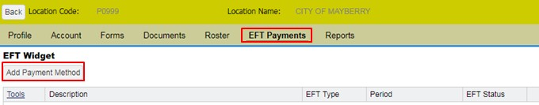

## Adding a Payment Account

1. Click the **‘Add** **Payment Method**’ button.

The **Details**pop-up window displays.

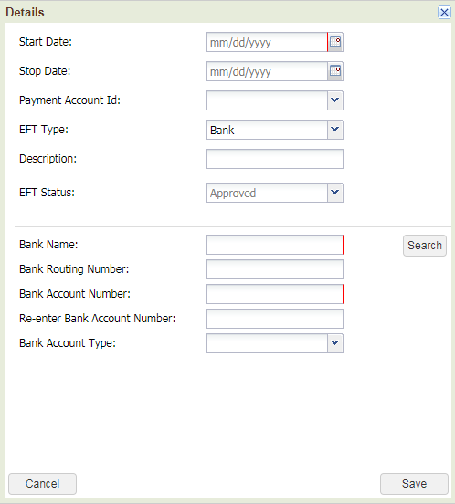

1. Complete the following fields:

* **Start Date:** Enter the appropriate start date. *Start date of the account, usually today.*
* **Stop Date:** Enter a stop date **only** if you wish to end use of your payment account. *Otherwise, this field should be left blank for future payments.*
* **Payment Account ID:** From the drop down select either **‘Contributions’** or **‘Enrollment’.** *Please Note: This field is for your informational purposes only.  Regardless of the payment account label you select, the payment will still be applied to the selected transaction type.*
* **EFT Type:** From the drop down select either **‘Bank’** or **‘Credit’**.
* **Description:** Enter an appropriate description which describes the account you are using. Examples: *MainePERS payroll* or *MainePERS GLI.*
* **Bank Name:** Click on the ‘Search’ button and type in first name of bank. If the bank is pre-existing in our system the routing number will automatically populate. If the bank has multiple routing numbers, please locate the one that corresponds to your account. If your bank does not appear in the search, please contact MainePERS.
* **Bank Account Number**: Enter (and re-enter) Account Number.
* **Bank Account Type**: Select Checking or Savings.

1. Click **‘Save’**.
2. Click **‘Confirm’** to permanently save the addition of your payment account.

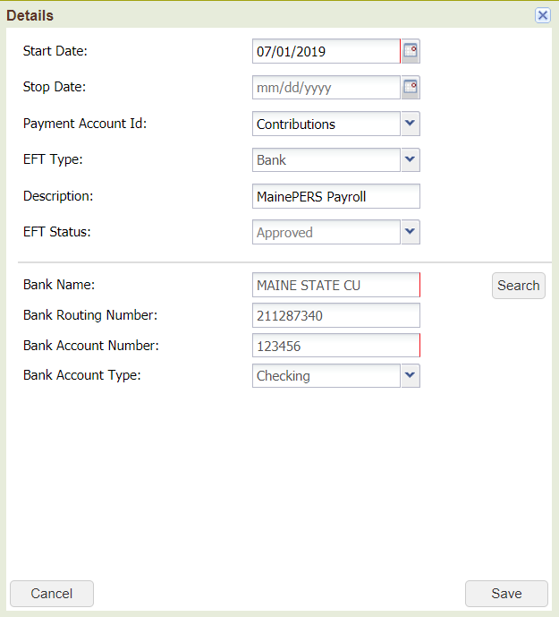 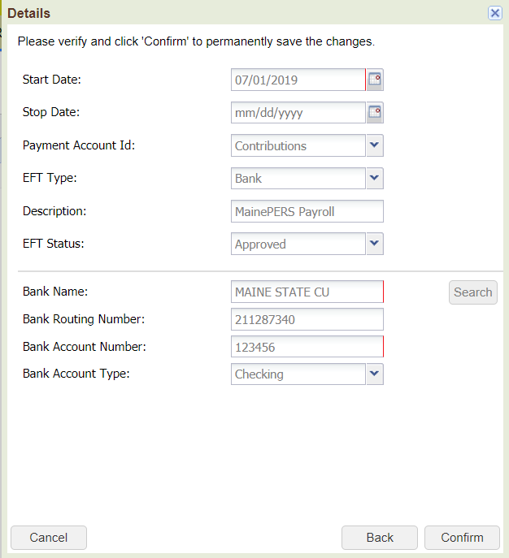

The **Details**pop-up window closes.

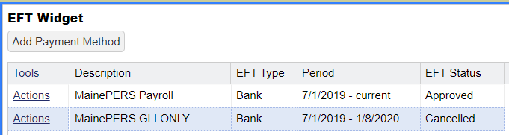

Cancelling a Payment Account

You may set the **EFT Status** of a payment account to **Cancelled**. This would be used if you change banks or accounts. If **Cancelled** is clicked in error, please contact Employer Reporting for guidance (1-800-451-9800).

Navigate to the payment account to be cancelled.

1. Click **‘Actions’** and select **‘Cancel’** from the drop-down.

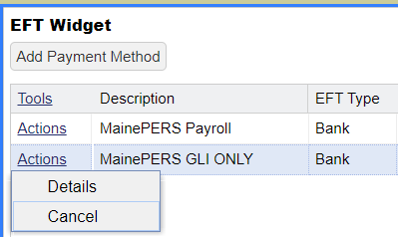

1. The setting in the **EFT Status** column changes to **Cancelled**.



**Scheduling an Electronic Funds Transfer (EFT) Payment**

There are two ways to schedule a payment to MainePERS within the Employer Self-Service System:

* **‘Pay this Transaction’ Option** – allows for an exact payment of one transaction at a time (may not adjust the due amount).
* **‘Schedule Payment’ Option** – allows for payment of one or more transactions at a time and the due amount may be adjusted. NOTE: If you are paying more or less than what is due to MainePERS, please make sure you notify your Employer Reporting Account Associate of the reason for the different payment amount.

**Note**: *These instructions* ***do not*** *apply to payments for Defined Contribution (DC) files. Please contact the Employer Reporting Unit if you have questions about making DC file payments.*

**‘Pay This Transaction’ Option:** Allows the employer to select an individual transaction to schedule a payment for the exact due amount only.

1. From the **‘Account’** screen, locate the transaction you are looking to schedule a payment for in the account details listed on this screen.
2. Once you have located the transaction, select the **‘Actions’** option.
3. From the drop down menu click **‘Pay this Transaction’**.

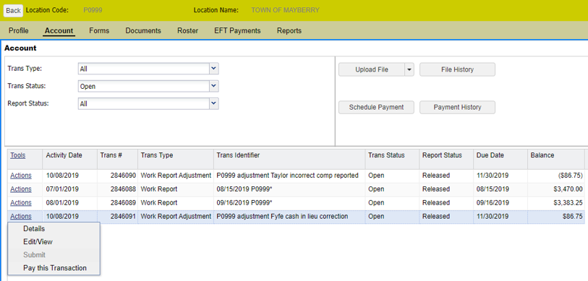

1. Selecting this action will cause the ‘**Make Payment Wizard**’ to generate. This wizard will guide you through scheduling the electronic payment.

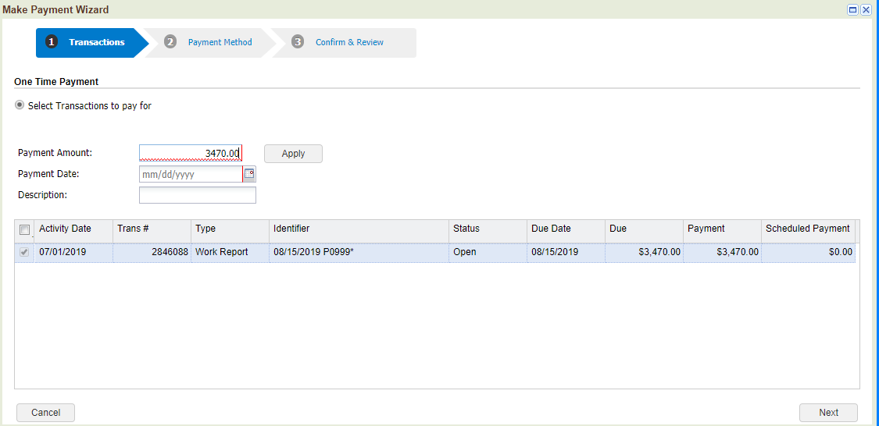

1. Complete **‘One-time Payment’** transaction details.

* **Payment Amount**: The payment amount will automatically populate the amount due for the selected transaction. This is a ‘read-only’ field. You can only schedule the payment for the exact amount due.
* **Apply Button**: Though visible, this button is ‘inactive’.

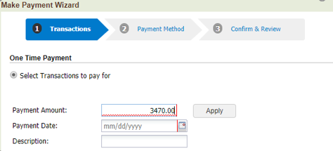

* **Payment Date:** Enter the date you would like the payment to be withdrawn from your account.

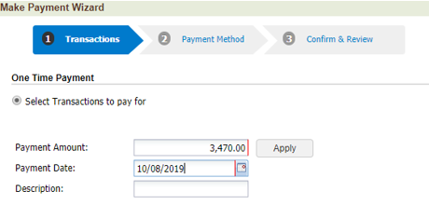

* **Description**: Enter a description for the payment, i.e. **‘July Payroll Payment’.** Although a description is not required, this field is intended for your informational purposes and can help differentiate multiple payments from one another, such as Payroll Work Report payments versus Group Life Insurance (GLI) Invoice payments.

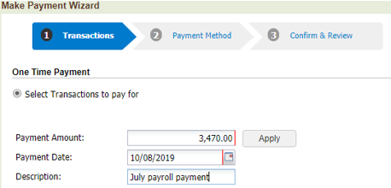

1. Click **‘Next’**. This will advance you to the **‘Payment Method’** screen.

**Note**: ***If there is no previously established bank account on file with MainePERS****, you will be directed to the following screen, which will walk you through the process for setting up your banking information. Please proceed to* ***Step 7*** *for instructions on completing your banking information details.*

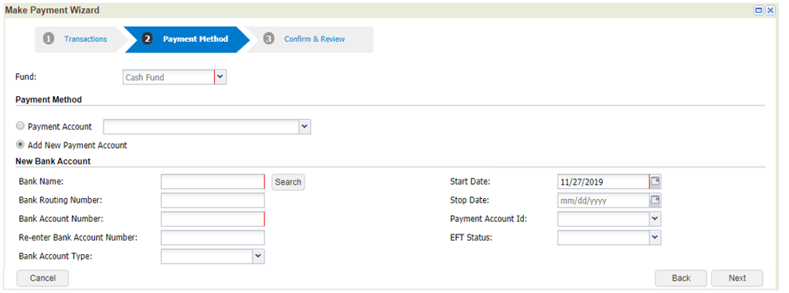

**If there is already a previously established bank account on file with MainePERS**, you will be directed to the following screen to make a selection:

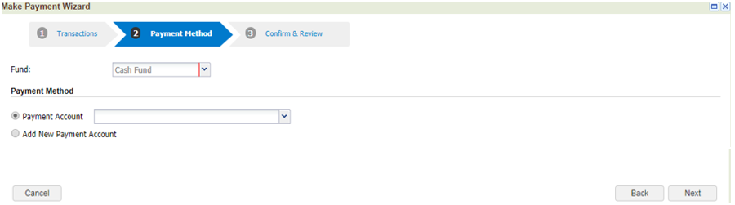

From here you must select **one** of the following two Payment Method options:

* **Payment Account**: Select a previously established bank account you would like to use for the payment from the drop-down menu (you must click on the drop-down arrow  to view account(s) on file). Click on the account you wish to use, then click ‘**Next’** and proceed to **Step 8** of these instructions.

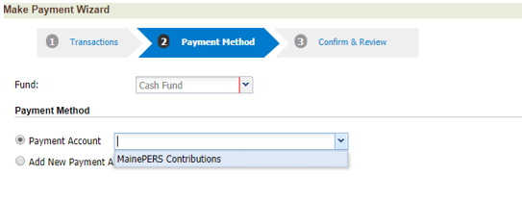

* **Add New Payment Account:** Selecting this option will allow you to set up a different or additional bank account during the EFT Payment process. Select the radio button next to this option and click ‘**Next’**. Proceed to **Step 7**.

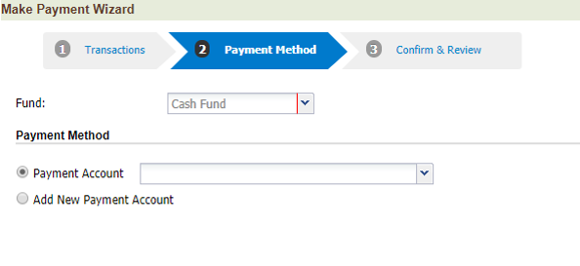

1. Complete requested **‘New Bank Account’** fields**.** When completed, select ‘**Next’**.

* **Bank Name**: Click on the ‘Search’ button and type in the name of bank. If the bank is pre-existing in our system, the routing number will automatically populate. If the bank has multiple routing numbers, please locate the one that corresponds to your account. If your bank does not appear in the search, please contact MainePERS.
* **Bank Routing Number**: Populated based on the bank search selection.
* **Bank Account Number**: Enter (and re-enter) Account Number
* **Bank Account Type**: Select Checking or Savings
* **Start Date**: Enter Today’s date, or a future date to take effect
* **Stop Date**: Should be left blank
* **Payment Account ID:** From the drop down select either **‘Contributions’** or **‘Enrollment’.** *Please Note: This field is for your informational purposes only.  Regardless of the payment account label you select; the payment will still be applied to the selected transaction type.*
* **EFT Status:** Select ‘**Approved’**

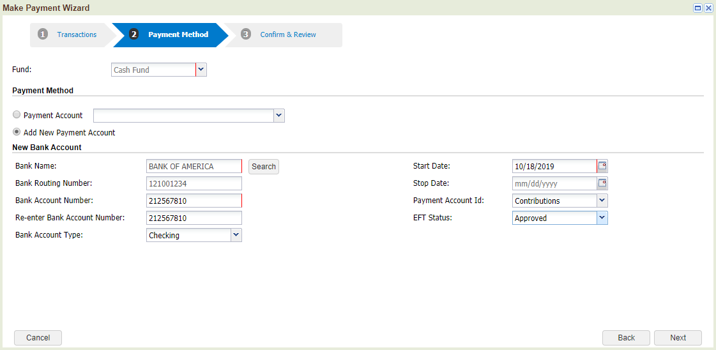

1. This will advance you to the **‘Confirm & Review’** screen.

* Review the information on this screen for accuracy; use the **‘Back’** button to make changes to any of this information.

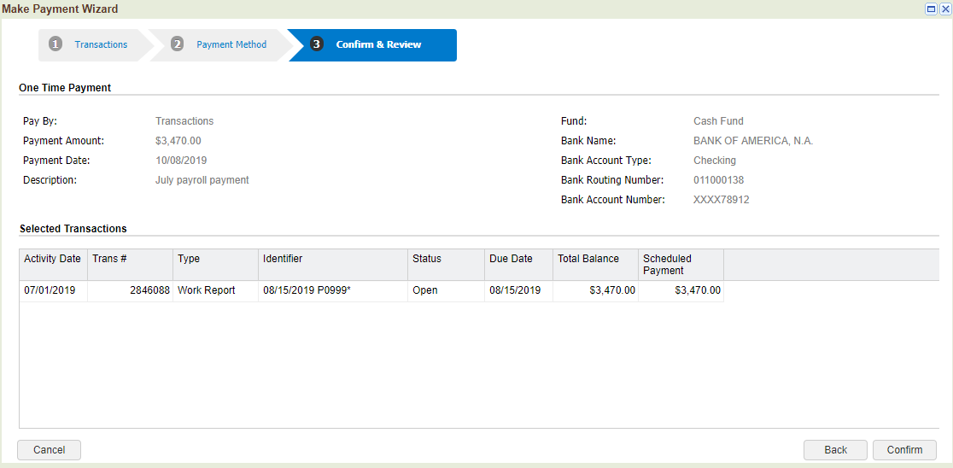

1. Click ‘**Confirm’** to submit. Once complete you will receive the following message.

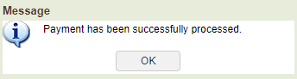

**Note**: *If you see a credit on your account (due to an adjustment or an overpayment, for example), please contact your Employer Reporting Account Reconciler to ensure this credit is applied to a future payroll. It is expected that credits will be taken by the employer as soon as administratively possible.*

**‘Schedule Payment’ Option:** Allows the employer to schedule a payment for one or more transactions at a time and schedule an amount higher or lower than the due amount.

1. From the **Account** screen, locate and click on the ‘**Schedule Payment’** button.

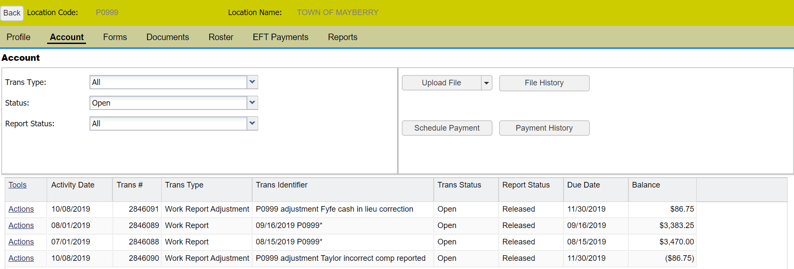

1. Selecting this action will cause the ‘**Make Payment Wizard**’ to generate. This wizard will guide you through scheduling the electronic payment.

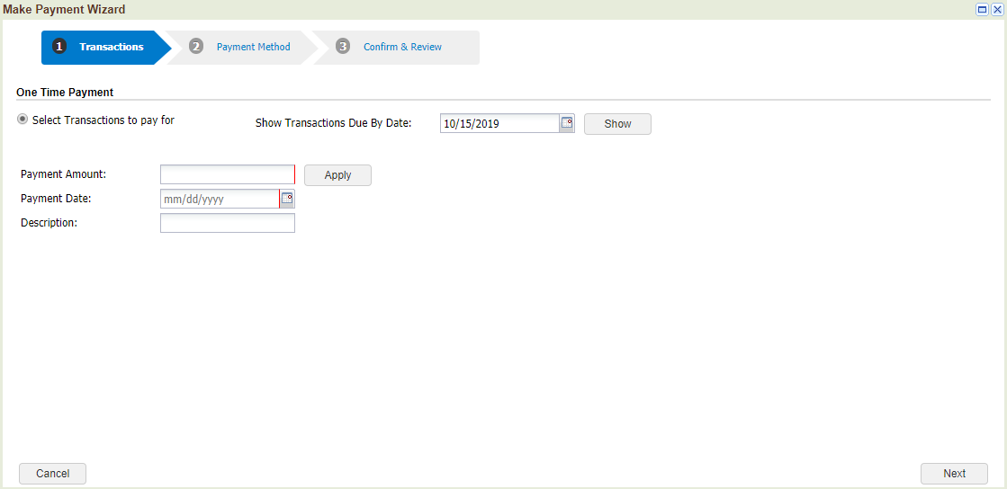

1. Under the ‘**One Time Payment’** section you will select the transactions you want to schedule a payment for. The **‘Show Transactions Due by Date’** field will automatically populate with the current date. Click the **‘Show’** button to display transactions due a payment (nothing will show until this step is complete)

***Note: Changing this date to a future date (i.e. three or six months in the future) will allow you to see all outstanding transactions that may have a future due date (i.e. work report adjustments, etc.).***

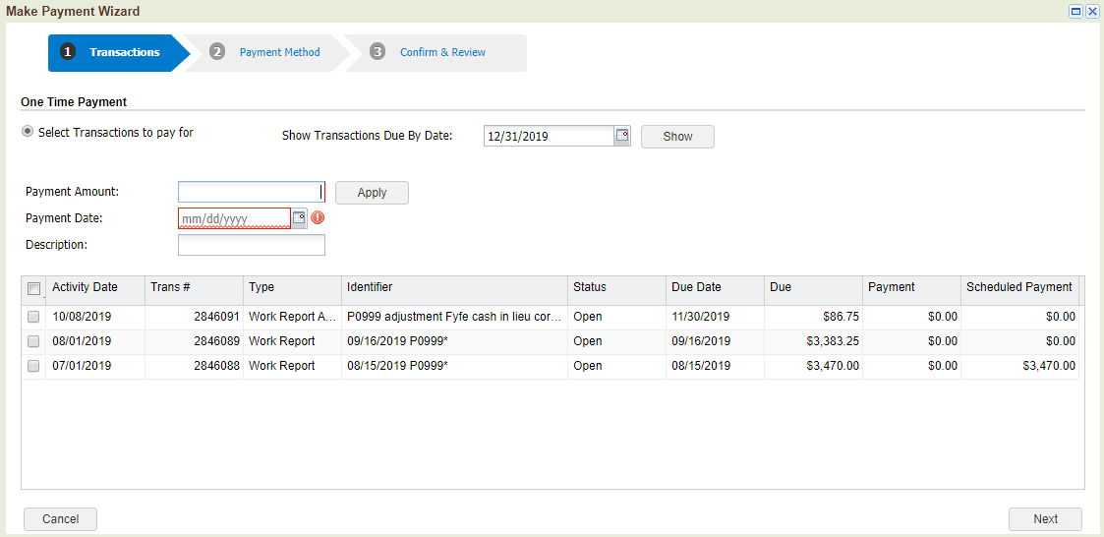

* **Payment Amount**: The Payment Amount field is ‘read-only’ and will display the total amount being scheduled. You will enter any payment details directly into the individual transaction(s).
* **Apply Button:**  Though visible, this button is ‘inactive’.

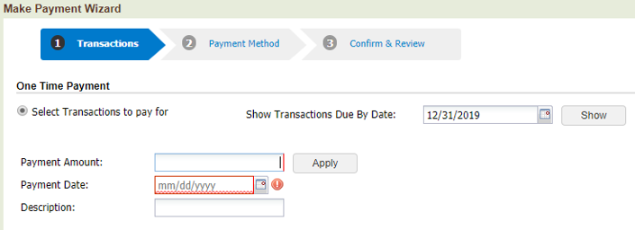

* **Payment Date:** Enter the date you would like the payment to be withdrawn from your account.

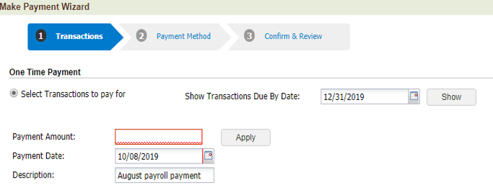

* **Description**: Enter a description for the payment, i.e. **‘August Payroll Payment’.** Although a description is not required, this field is intended for your informational purposes and can help differentiate multiple payments from one another, such as Payroll Work Report payments versus Group Life Insurance (GLI) Invoice payments.

**

To schedule the payment, select the checkbox on the left side of the row for each individual transaction being scheduled. Selecting each transaction will populate the corresponding ‘Payment column’ with the total payment amount due for that transaction. The transaction amount may be adjusted within the ‘Payment column’, if desired. This action will also calculate the total amount due based on the selected transaction(s) in the ‘Payment Amount’ field.

**Remember:** If you are paying more or less than what is due to MainePERS, please make sure you notify your Employer Reporting Account Associate of the reason for the different payment amount.

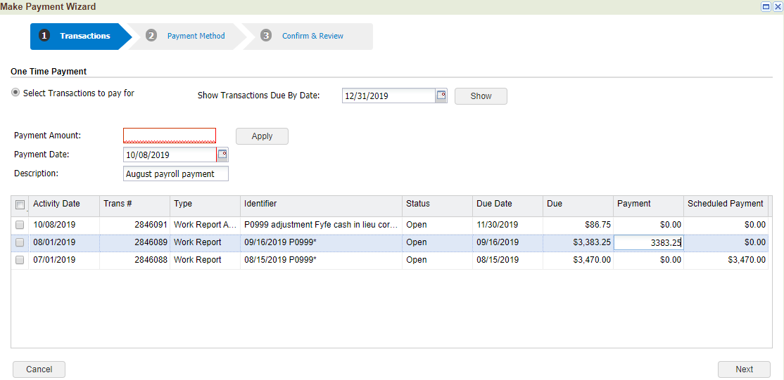

1. Click **‘Next’**. This will advance you to the ‘**Payment Method’** screen.

**Note**: ***If there is no previously established bank account on file with MainePERS****, you will be directed to the following screen, which will walk you through the process for setting up your banking information. Please proceed to* ***Step 5*** *for instructions on completing your banking information details.*



**If there is already a previously established bank account on file with MainePERS**, you will be directed to the following screen:



From here you must select only one of the following two Payment Method options:

* **Payment Account**: Select a previously established bank account you would like to use for the payment from the drop-down menu (you must click on the drop-down arrow to view account(s) on file). Click on the account you wish to use, click ‘**Next’** and proceed to **Step 6** of these instructions.



* **Add New Payment Account:** Selecting this option will allow you to set up a new or additional bank account during the EFT Payment process. Select the radio button next to this option and click ‘**Next’**. Proceed to **Step 5**.

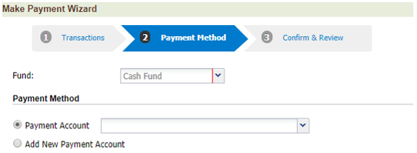

1. Complete requested **‘New Bank Account’** fields**.** When completed, select ‘**Next’**

* **Bank Name**: Click on the ‘Search’ button and type in first name of bank. If the bank is pre-existing in our system, the routing number will automatically populate. If the bank has multiple routing numbers, please locate the one that corresponds to your account. If your bank does not appear in the search, please contact MainePERS.
* **Bank Routing Number**: Populated based on the bank search selection.
* **Bank Account Number**: Enter (and re-enter) Account Number
* **Bank Account Type**: Select Checking or Savings
* **Start Date**: Enter Today’s date, or a future date to take effect
* **Stop Date**: Should be left blank
* **Payment Account ID:** From the drop down select either **‘Contributions’** or **‘Enrollment’.** *Please Note: This field is for your informational purposes only.  Regardless of the payment account label you select; the payment will still be applied to the selected transaction type.*
* **EFT Status:** Select ‘**Approved’**



1. This will advance you to the **‘Confirm & Review’** screen.

Review the information on this screen for accuracy; use the **‘Back’** button to make changes to any of this information.



1. Click ‘**Confirm’** to submit. Once complete you will receive the following message.



**Note**: *If you see a credit on your account (due to an adjustment or an overpayment, for example), please contact your Employer Reporting Account Reconciler to ensure this credit is applied to a future payroll. It is expected that credits will be taken by the employer as soon as administratively possible.*